 | Directorate B: Statistical methodologies and tools  Unit B-3: Statistical information technologies

Design of the Web Service Provider Module (.NET)

Version 3.0
December 2013

Table of Contents Page
Terms and abbreviations 4
1 Introduction 5
1.1 Non-functional requirements 6
2 Architecture 6
3 Component and Logical View 10
3.1 NSIStdV20Service, NSIEstatV20Service 13
3.2 XmlStreamWrapper 13
3.3 Controller classes 13
3.4 DataQueryParserManager 13
3.5 CompactDataWriterEngine, GenericDataWriterEngine, CrossSectionalWriterEngine 13
3.6 ISdmxDataRetrievalWithWriter, IAdvancedSdmxDataRetrievalWithWriter, ISdmxDataRetrievalWithCrossWriter, DataRetrieverCore 13
3.7 StructureRetriever 14
3.8 QueryParserManager, ConstraintQueryBuilderV2 14
4 Package View 14
5 Dynamic View 16
Annex A: Supported extensions to SDMX v2.0 21
1. Updated “QueryStructureRequest” with attribute “returnDetails” 21
2. Available codes request 23
6 Annex B: Diagram Documentation for Dataflow in Production feature. 24
6.1 Introduction 24
6.1.1 Purpose 24
6.1.2 Affected components 25
6.1.3 Background of Dataflow Production flag 25
6.2 Mapping Assistant 25
6.3 NSI Web Service (Java/.NET) 28
6.4 NSI Client 32
6.5 Test Auth Config 34
6.6 Test Client 35

List of figures Page
Figure 1 - SDMX Reference Infrastructure 7
Figure 2 - Component View 10
Figure 3 - Simple Logical View 12
Figure 4 - Package diagram 15
Figure 5 - Sequence diagram for querying data 17
Figure 6 - Sequence diagram for querying structural metadata 18
Figure 7 - Sequence diagram for authentication/authorization 19
Figure 8 - Codelist request for FREQ dimension for Dataflow SSTSIND_PROD_M 23
Figure 9 - Codelist request for REF_AREA dimension for Dataflow SSTSIND_PROD_M with FREQ set to ‘M’ 24
Figure 10 : Activity diagram showing the Set Dataflow in production steps. 26
Figure 11: Mapping Assistant Indicative error message when a dataflow cannot be set in production. 27
Figure 12: NSI WS activity diagram for Get*Data requests using a version of NSI WS with new dataflow in Production feature. 28
Figure 13: NSI WS activity diagram for Get*Data request using a version of NSI WS without the new dataflow in Production feature. 29
Figure 14: NSI WS activity diagram for GetQueryStructure request using a version of NSI WS with the new dataflow in Production feature 30
Figure 15: NSI WS activity diagram for GetQueryStructure request using a version of NSI WS without the new dataflow in Production feature 31
Figure 16: The sequence diagram of NSI Client that uses an NSI WS version that includes the new feature. 32
Figure 17: The sequence diagram of NSI Client that uses an NSI WS version that does not include the new feature 33
Figure 18: Test Auth Config that does not include support for the Dataflow in Production new feature. 34
Figure 19: Sequence diagram of a user with a version of Test Client that includes the new Dataflow in Production feature. 35
Figure 20: Sequence diagram of a user with a version of Test Client that without the new Dataflow in Production feature. 36
Figure 21: Activity flow of GenerateData with a version of Test Client that includes the new Dataflow in Production feature 37
Figure 22: Activity flow of GenerateData with a version of Test Client without the new Dataflow in Production feature 38

List of tables Page
Table 1: Terms and Abbreviations 5
Table 1: Return details possible values. 21
Table 2: The list of components that are directly affected by this change. 25

Document Change Record
Issue/ Revision | Date | Change
1.0 | 01/10/2012 | This version of the document applies to NSI Web Service (.NET) v2.4.4.  The modifications included in this version are:  - Changed the location for the section “Terms and abbreviations” to the beginning of the document.
1.1 | 11/07/2013 | This version of the document applies to NSI Web Service (.NET) v2.4.5  - Added section 7 – Annex B: Diagram Documentation for Dataflow in Production feature.  - Updated section 1 - Introduction  Note! The workflow has changed. Please consult section Introduction
2.1 | 27/08/2013 | Alignment with the intermediate version
3.0 | 12/12/2013 | Alignment with SDMX 2.1 version
3.1 | 31/08/2014 | Sections updated  - Section 1. Specify SDMX v2.1 query messages.  - Section 3.6. Replace QueryParser with IDataQueryParsingManager  - Annex A: Correct SDMX version.  Sections added:  - Non-Functional requirements. Refer to “Re-Using Web Service Provider Module (.NET)”.

Terms and abbreviations

Acronym | Definition
NSI | National Statistical Institute
NSI WS | National Statistical Institute Web Service
SDMX | Statistical Data and Metadata eXchange
SDMX-ML | SDMX-ML(using XML syntax)
SOAP | Simple Object Access Protocol is a protocol specification for exchanging structured information in the implementation of Web Services in computer networks.
EUPL | European Union Public License
URL | Uniform Resource Locator
BB | Building Block
Table 1: Terms and Abbreviations

Introduction

The objective of this document is to present the design of the NSI Web Service intended for enabling Member States to expose their dissemination database, using Web Services technologies, in SDMX-ML format. In order to facilitate the adoption and integration of this Web Service, it was developed in both Java and .NET platforms, this document referring to the latter. In this way an NSI dissemination environment will be able to support modern data transmission schemes that will facilitate potential Data Consumers have access to it (e.g. Eurostat using the SODI pull transmissions).
The ultimate goal of this attempt is to enable NSIs adopt the SDMX Reference Infrastructure, thus increasing the interoperability and visibility of their dissemination environment and thereby reducing the burden for distributing data to potential Data Consumers.

Warning
Since the version 2.4.5 of NSI WebService a new Dataflow flag/attribute called “Production” has been introduced. This Production flag indicates whether a Dataflow can be used for querying data. If a dataflow is not set into Production the NSI Web service will not serve any query request using that dataflow.
Any NSI WebService client (from version 2.4.5) is affected by this change (including NSI WebClient, TestClient) .
The web methods of NSI web service affected by this change are Get*Data (Compact, Generic, CrossSectional, StructureSpecific), GetQueryStructure, GetDataflowQuery, GetCategorisationQuery, GetCategorisationSchemeQuery and GetDataStructureQuery.
The Production flag of a dataflow has two potential values:
- Value 1: indicates that the dataflow can be used by NSI WebService to serve query requests using the respective dataflow
- Value 0: indicates that the dataflow cannot be used by NSI WebService to serve query requests.
The Production flag for dataflow can be set from the Mapping Assistant tool. For more information about setting or removing form Production a dataflow please check the Mapping Assistant User Manual and Tutorial v1.4.doc – section 2.12.4
For more information about the flow and algorithms of the Production flag please check section 7 - Annex B: Diagram Documentation for Dataflow in Production feature.

Non-functional requirements
For the list of non-functional requirements please refer to “Re-Using Web Service Provider module (.NET)” at the correspond section, “Non-functional requirements”.

Architecture
The following diagram depicts a proposed architecture for a potential Data Provider (i.e. an NSI) in order to be able to participate in transmissions using metadata driven Dataset production.
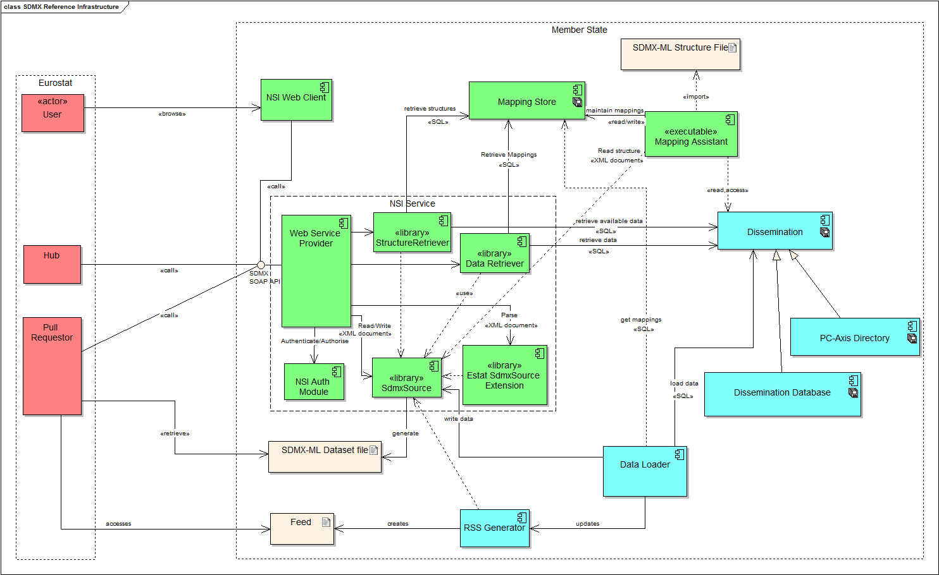
Figure 1 - SDMX Reference Infrastructure
The objective of the current document is to analyse the Web Service part of this architecture. More specifically, the following components comprise the Web Service part of the NSI:
- Web Service Provider
- Data Retriever
- Structure Retriever
- NSI Auth Module
- SdmxSource (.NET)
- Estat SdmxSource Extension

This Web Service is responsible for exposing data stored in the Dissemination database, according to the metadata stored in the Mapping Store database. Thus, from the NSI Web Service perspective, these two databases are considered as actors to its usage.
Another important (although indirect from WS perspective) actor is the Mapping Assistant tool that populates the Mapping Store with metadata; the latter relate the contents of the Dissemination database to an SDMX DSD. These metadata are also required by the Data Retriever, which is responsible for querying the Dissemination database according to an SDMX-ML Query targeted to data of the aforementioned DSD.
Moreover, the components of the Web Service make use of the SdmxSource component, (aka SDMX Common API) which provides and API and an implementation for representing SDMX information based in the SDMX-IM as well as for parsing and writing SDMX-ML messages. Besides this there is the Estat SdmxSource Extension module which adds more features that are required by the SDMX Reference Infrastructure that are not included in the SdmxSource. For instance it includes parsing and writing of custom requests for available codes in a DDB.

In the above diagram (Figure 1 - SDMX Reference Infrastructure), the WS is presented in the context of the SDMX Reference Infrastructure and all the aforementioned components that comprise this WS are now included in a border. These are the components that are foreseen to be developed in the context of the NSI Web Service. Of course, since the mappings are required in order to retrieve data from a dissemination database, the Mapping Assistant tool shall be used. Moreover, a proposed schema for a dissemination database shall be introduced, in the (rare) case that an NSI would not use an existing Dissemination database.

Component and Logical View

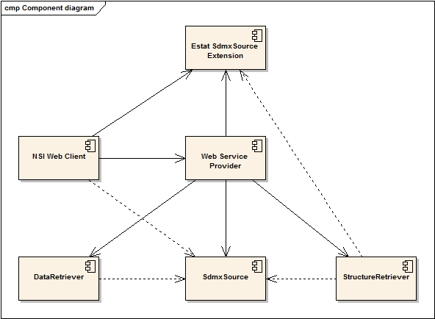
Figure 2 - Component View

The NSI Web Service has the following modules:
- Web Service Provider: this module implements the Web Service SOAP interface, and is also responsible for the control of the order to which the other modules are invoked.
- SdmxSource: in the context of the SDMX RI Web Service, this module is responsible for the parsing of the SDMX-ML Query and writing SDMX-ML datasets and SDMX-ML structures. In general, the SdmxSource provides the possibility to read and write SDMX-ML messages.
- Data Retriever: this module is responsible for the generation of an SQL query which is equivalent to the SDMX Query. It also executes the query on the Dissemination Database, and uses the SdmxSource write data directly to SDMX-ML. Data Retriever implements the SdmxSource interfaces for data retrieval.
- Structure Retriever: This module is responsible for retrieving structural metadata from the Mapping Store database. It can also return partial codelists based on the available data from the Dissemination Database. Structure Retriever implements the SdmxSource interfaces for structure retrieval.
- Estat SdmxSource Extension: This module is responsible for reading and writing custom requests that come from the NSI Web Client to get partial codelists based on available data. Also it offers specialised beans for keeping query information of the custom requests.
This section presents a simplified logical view with the main classes/interfaces of each module. The main classes are:
- the NSIStdv20Service acting as a controller for the Web Service Wrapper module
- the DataQueryParseManager, QueryParsingManager, RegistryInterfaceReaderV2, RegistryInterfaceWriterV2 classes and ISeriesWriter and ICrossSectionalWriter for the SDMXSOURCE module,
- the ISdmxDataRetrievalWithWriter and IAdvancedSdmxDataRetrievalWithWriter interfaces for the Data Retriever module
- the IMutableStructureSearchManager interface for the Structure Retriever module.
Each of these classes has specific functionality, and together they achieve the complete functionality of the NSI Web Service.

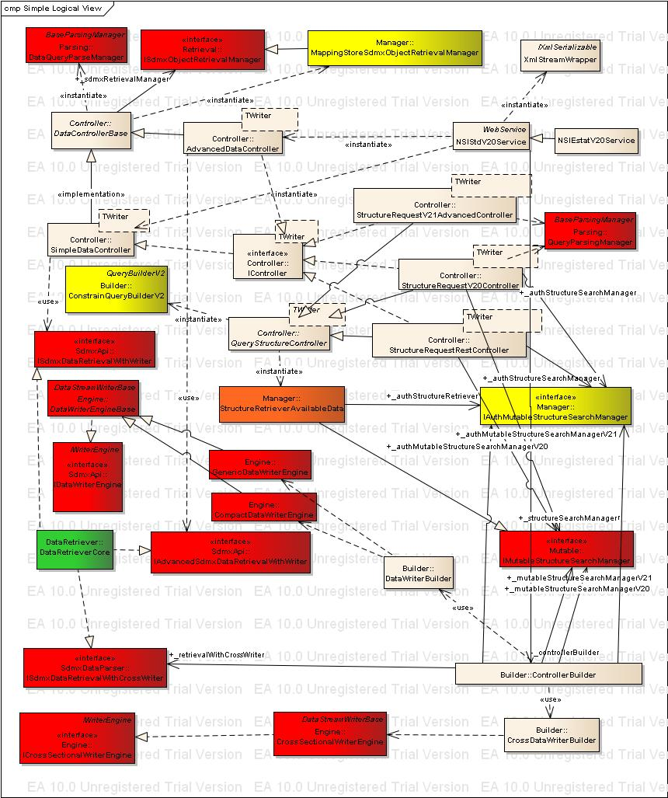
Figure 3 - Simple Logical View
The diagram in Figure 3 shows the main classes and their interaction. The colouring and layout of the diagram follow the ones in the component view (Figure 2). Going through the classes presented in the logical view, the functionality of the NSI WS will be presented below.

NSIStdV20Service, NSIEstatV20Service
These classes are responsible for exposing the functionality of the NSI WS using SOAP as a Web Service. As their name reveals, they are wrapper classes implementing the SOAP interface upon the functionality offered.

XmlStreamWrapper
XmlStreamWrapper is the return type of the web methods and this class enables streaming of the responses to the client. When an instance of this class is instructed to serialize, it will initiate the data retrieval and stream the results back to the requestor.

Controller classes
These classes are responsible for co-ordinating the flow of events within the NSI WS.

DataQueryParserManager
This class is responsible for parsing incoming data SDMX-ML Query messages and storing them in SDMX API model.

CompactDataWriterEngine, GenericDataWriterEngine, CrossSectionalWriterEngine
These classes are responsible for writing SDMX-ML Data messages. They are used by the ISdmxDataRetrievalWithWriter and ISdmxDataRetrievalWithCrossWriter implementations to write SDMX-ML Data. The ISdmxDataRetrievalWithCrossWriter is used with CrossSectionalWriterEngine.

ISdmxDataRetrievalWithWriter, IAdvancedSdmxDataRetrievalWithWriter, ISdmxDataRetrievalWithCrossWriter, DataRetrieverCore
DataRetrieverCore is considered the most important class of the NSI Web Service, as well as the most complicated. The DataRetrieverCore uses the Mapping Store in order to resolve the incoming query (stored already in the internal data model by the IDataQueryParsingManager). Its main responsibility is to translate the incoming SDMX-ML Query into an SQL Query that will be used for retrieving data from the Dissemination database. It will use a CompactDataWriterEngine, GenericDataWriterEngine or a CrossSectionalWriterEngine to write the results to SDMX-ML data.
ISdmxDataRetrievalWithWriter, IAdvancedSdmxDataRetrievalWithWriter and ISdmxDataRetrievalWithCrossWriter are the main interfaces of the DataRetriever module. The DataRetrieverCore implements those interfaces.

StructureRetriever
The StructureRetriever uses the Mapping Store in order to resolve the incoming Query Structure request (stored already in the internal data model by the SDMXSOURCE Registry Interface Reader). Its main responsibility is to translate the incoming Structure queries requests into an SQL Query that will be used for retrieving structural metadata from the Mapping Store database. For codelists requested together with a dataflow reference with constrains, it will retrieve a partial codelist based on the available data from the Dissemination database and on the constraints of the dataflow reference. It implements the IMutableStructureSearchManager from SDMX Source API and IAuthMutableStructureSearchManager.

QueryParserManager, ConstraintQueryBuilderV2
This class is responsible for parsing incoming SDMX ML Structure Query messages and storing them in the SDMX API model. The ConstrainQueryBuilderV2 is used to handle the custom requests.

Package View
This section presents the packages of the NSI Web Service. In each package, the reader will be able to discern the main classes presented in a previous section.

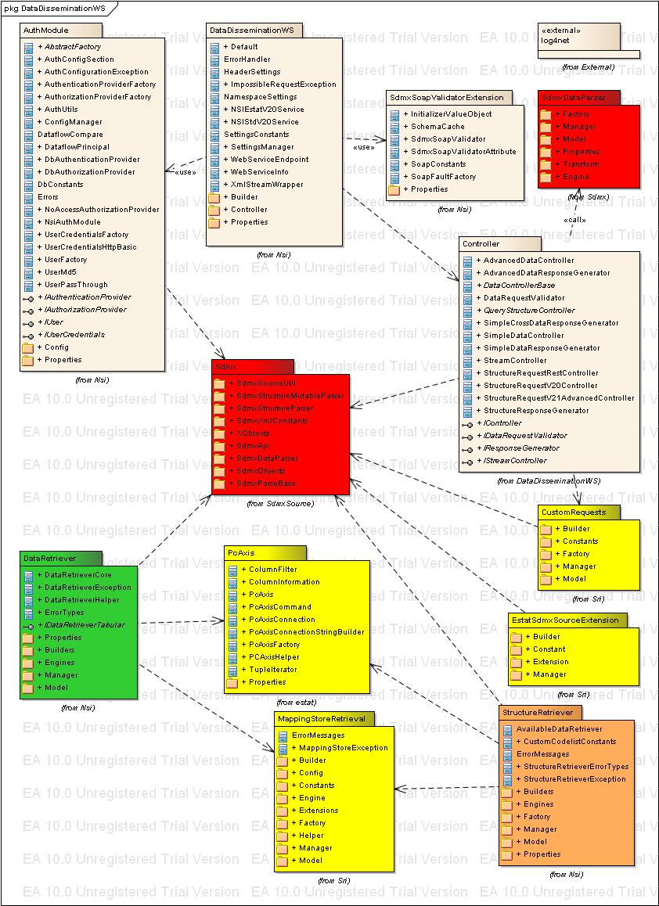
Figure 4 - Package diagram
The above figure shows the packages of the NSI WS, as well as their associations with other modules and their packages. The colouring of the diagram follows the diagram for the component view depicted in Figure 2
From the figure above, only the DataDisseminationWS, Controller, AuthModel and SdmxSoapValidationExtension packages belong to the NSI WS module. The Sdmx and SdmxDataParser package belongs to the SDMXSOURCE module (red colour). The packages in green colour belong to the Data Retriever. The packages in yellow are used by multiple packages or are helper packages, including the CustomRequests, EstatSdmxSourceExtyension, the MappingStoreRetrieval and the PcAxis. The package in orange belongs to the Structure Retriever. The log4net is a external dependency used by all packages.

The DataDisseminationWS package of the NSI WS is responsible for exposing the SOAP interface, through which it receives requests and passes them to the Controller package responsible for calling the DataQueryParseManager class of the SdmxSource module to parse the query contained in the received request. The query is modelled as a IDataQuey (from SmdxSource). The Controller also calls a stream writer of the SmdxSource package and is used together with the IDataQuery to invoke the DataRetriever package of the Data Retriever module, which populates classes from the SdmxSource package to get Mapping information from MA Store (also of the Data Retriever). Note that in the case of PC-Axis files used as a Dissemination Database, it initially invokes its PC-Axis module which converts a PC-Axis file into an in-memory database.

Dynamic View
This section presents a sequence diagram showing the interaction between the modules, as well as the exact inputs and outputs of each invocation.
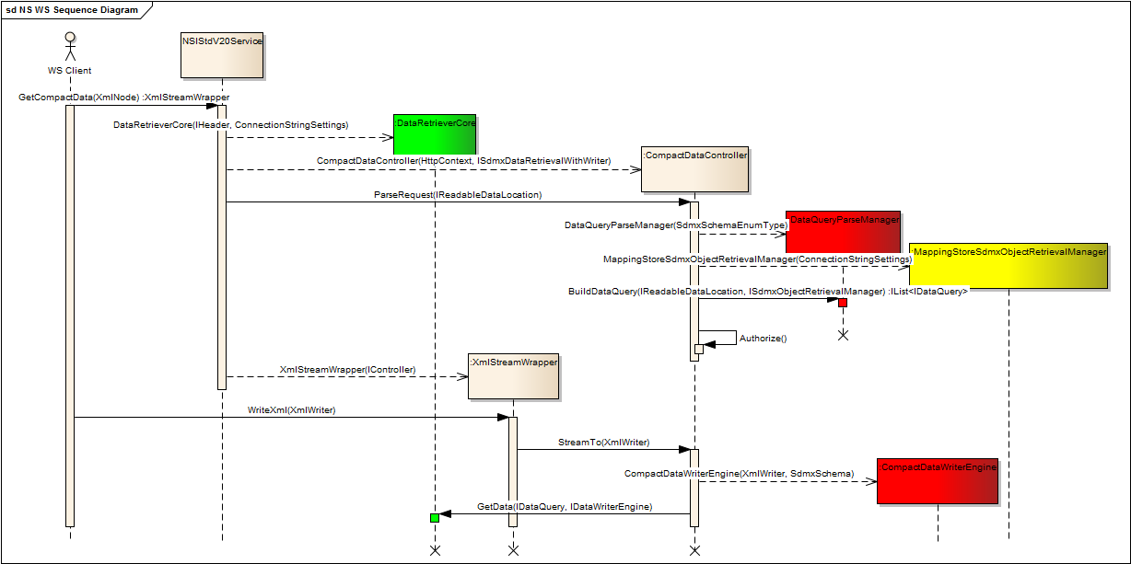
Figure 5 - Sequence diagram for querying data
In the case of querying data, the following steps are executed:
- Initially the Web Service Provider module is called by a Web Service client. Specifically, one of its operations (in the example GetCompactData) is invoked.
- The Web Service Provider instantiates the DataRetrieverCore default SDMX Header and MASTORE connection settings.
- The Web Service Provider instantiates the format specific IController implementation, in this example the CompactDataController with the DataRetrieverCore from the previous step.
- The CompactDataController instantiates the DataQueryParsingManager and calls its BuildDataQuery() method. It also instantiates MappingStoreSdmxObjectRetrievalManager which is needed by DataQueryParsingManager. The inputs required for this invocation are the location of the XML Schema for the SDMX Query (for the constructor) and the InputStream for the query of the request (for the Read() method). The DataQueryParsingManager returns a list of IDataQuery of the SDMX Source, representing the SDMX Query.
- The CompactDataController checks if the WS Client is authorized to access the dataflow from the IDataQuery. If not it throws an exception.
- The Web Service provider instantiates an XmlStreamWrapper with the IController implementation instance, in this example CompactDataController from step 3 and returns the XmlStreamWrapper instance.
- The ASP.NET web service stack calls the WriteXml method of the XmlStreamWrapper instance, in which it calls the StreamTo() method of the supplied CompactDataController from step 7 with the provided XmlWriter.
- The CompactDataController creates a new CompactWriter instance with the provided XmlWriter and invokes the DataRetrieverCore GetData() method. The inputs required for this invocation are the previously populated IDataQuery and the CompactDataWriter instance, which are the arguments of the GetData() method. The DataRetrieverCore streams the data as it maps and transcodes it to the CompactDataWriter which writes the data to the supplied XmlWriter which output is streamed back to the Web Service client. The Web Service client receives the data as a SDMX-ML Compact data message enclosed in SOAP tags.
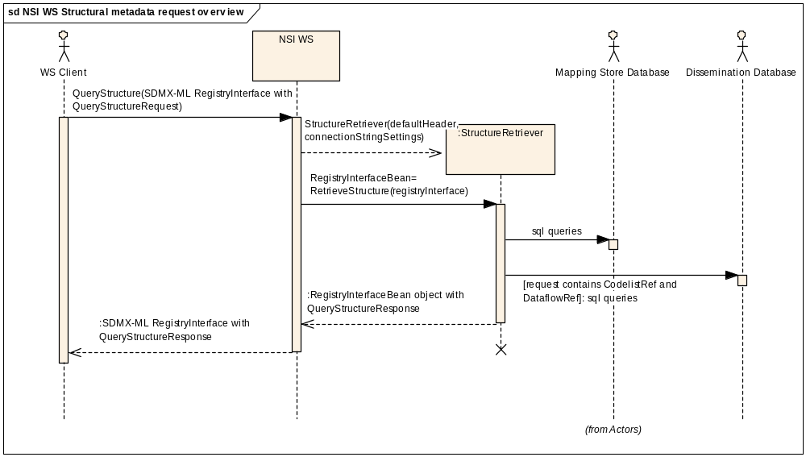
Figure 6 - Sequence diagram for querying structural metadata
In the case of querying structural metadata, the following steps are executed:
- Initially the Web Service Provider module is called by a Web Service client. Specifically it calls the QueryStructureRequest operation with a SDMX–ML RegistryInterface message containing a QueryStructureRequest.
- The Web Service Provider converts the incoming SDMX-ML RegistryInterface message to SDMX Source API model, initiates one of the IMutableStructureSearchManager implementation, StructureRetrieverAvailableData, and calls its RetrieveStructures() method.
- The StructureRetriever parses the query structure request and queries the Mapping Store database for the requested structural metadata. If the query structure request contains a codelist and a dataflow reference it will also query the dissemination database for available data for a requested dimension.
- The Structure Retriever will return IMutableObjects from SDMX Source with the requested structural metadata.
- Finally the Web Service Provider will convert the IMutableObjects to SDMX-ML, enclose it in a SOAP envelope and respond to the WS Client.
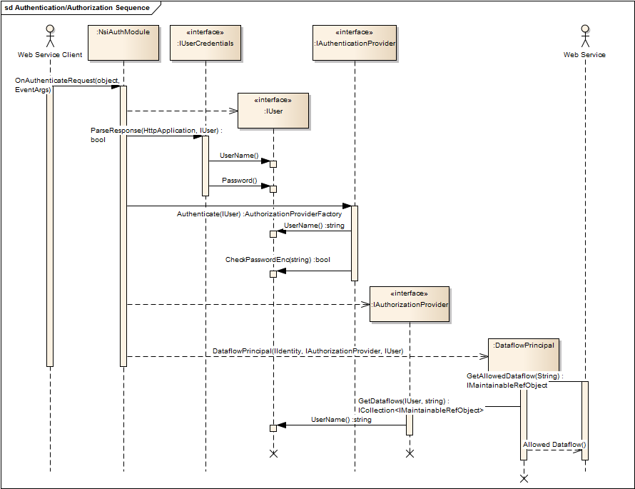
Figure 7 - Sequence diagram for authentication/authorization
In the case of authentication/authorization, the following steps are executed:
- A WebService Client software sends a request to the NSI Web Service. The NsiAuthModule intercepts the request and triggers the OnAuthenticateRequest event.
- The NsiAuthModule creates an IUser instance using the configured implementation.
- The NsiAuthModule calls the IUserCredentials instance, created during NsiAuthModule initialization, in order to parse the request and retrieve the user credentials and stores them in the IUser instance created in step 2.
- The NsiAuthModule calls the IAuthenticationProvider instance, created during NsiAuthModule initialization, in order to authenticate the user based on the user credentials from the IUser instance created in step 2.
- The NsiAuthModule creates an IAuthorizationProvider instance using the implementation configured.
- The NsiAuthModule creates a DataflowPrincipal instance with the IAuthorizationProvider instance created in step 5 and the IUser instance created in step 2.
- When the request reaches the NSI WS, the NSI WS controller calls the DataflowPrincipal created in step 6 and call various methods to get the allow dataflow(s) depending if the request is for data or structural metadata.The DataflowPrincipal passes the requests to the IAuthorizationProvider created in step 5.

Annex A: Supported extensions to SDMX v2.0

1. Updated “QueryStructureRequest” with attribute “returnDetails”

The ‘returnDetails’ is an optional XML attribute extension to the ‘QueryStructureRequest’ XML element of the SDMX RegistryInterface Message. It controls whether the NSI WS should return the “details” of the requested artefacts. The “details” can be codes, concepts, categories, components or references. For example the details for a CodeList artefact are the Codes while for a Dataflow the KeyFamilyRef and CategoryRef. The ‘SDMXRegistry.xsd’ needs to include the following definition under the complex type “QueryStructureRequestType”:

XML Schema Definition (XSD)
<xs:attribute name="returnDetails" type="xs:boolean" use="optional" default="true"/>

The ‘SDMXRegistry.xsd’ supplied in the NSI WS package already includes this definition.

Value | Description
true | Instructs the Web Service to return details. This is the default and the standard behaviour of SDMX v2.0.
false | Instructs the Web Service not to return details.
Table 2: Return details possible values.
Below there is an example request for all Category Schemes with returnDetails=”false” and the corresponding response without any Categories.
SOAP Request
<soapenv:Envelope xmlns:soapenv="http://schemas.xmlsoap.org/soap/envelope/" xmlns:web=" http://ec.europa.eu/eurostat/sri/service/2.0/extended">
<soapenv:Header/>
<soapenv:Body>
<web:QueryStructure>
<!--Optional:-->
<web:Query>
<RegistryInterface xsi:schemaLocation="http://www.SDMX.org/resources/SDMXML/schemas/v2_0/message SDMXMessage.xsd" xmlns="http://www.SDMX.org/resources/SDMXML/schemas/v2_0/message" xmlns:common="http://www.SDMX.org/resources/SDMXML/schemas/v2_0/common" xmlns:compact="http://www.SDMX.org/resources/SDMXML/schemas/v2_0/compact" xmlns:cross="http://www.SDMX.org/resources/SDMXML/schemas/v2_0/cross" xmlns:generic="http://www.SDMX.org/resources/SDMXML/schemas/v2_0/generic" xmlns:query="http://www.SDMX.org/resources/SDMXML/schemas/v2_0/query" xmlns:structure="http://www.SDMX.org/resources/SDMXML/schemas/v2_0/structure" xmlns:registry="http://www.SDMX.org/resources/SDMXML/schemas/v2_0/registry" xmlns:utility="http://www.SDMX.org/resources/SDMXML/schemas/v2_0/utility" xmlns:xsi="http://www.w3.org/2001/XMLSchema-instance">
<Header>
<ID>ESTAT014</ID>
<Test>true</Test>
<Truncated>false</Truncated>
<Name xml:lang="en">Trans46302</Name>
<Prepared>2001-03-11T09:30:47-05:00</Prepared>
<Sender id="4D0"/>
</Header>
<QueryStructureRequest resolveReferences="false" returnDetails="false">
<registry:CategorySchemeRef/>
</QueryStructureRequest>
</RegistryInterface>
</web:Query>
</web:QueryStructure>
</soapenv:Body>
</soapenv:Envelope>

SOAP Response
<?xml version="1.0" encoding="UTF-8"?>
<soap:Envelope xmlns:soap="http://schemas.xmlsoap.org/soap/envelope/" xmlns:xsi="http://www.w3.org/2001/XMLSchema-instance" xmlns:xsd="http://www.w3.org/2001/XMLSchema">
<soap:Body>
<QueryStructureResponse xmlns="http://ec.europa.eu/eurostat/sri/service/2.0/extended">
<QueryStructureResult>
<RegistryInterface xsi:schemaLocation="http://www.SDMX.org/resources/SDMXML/schemas/v2_0/message SDMXMessage.xsd" xmlns="http://www.SDMX.org/resources/SDMXML/schemas/v2_0/message" xmlns:common="http://www.SDMX.org/resources/SDMXML/schemas/v2_0/common" xmlns:registry="http://www.SDMX.org/resources/SDMXML/schemas/v2_0/registry" xmlns:structure="http://www.SDMX.org/resources/SDMXML/schemas/v2_0/structure">
<Header>
<ID>IT1001</ID>
<Test>true</Test>
<Name xml:lang="en">Trans46302</Name>
<Prepared>2001-03-11T09:30:47-05:00</Prepared>
<Sender id="IT"/>
<Receiver id="4D0"/>
</Header>
<QueryStructureResponse>
<registry:StatusMessage status="Success"/>
<registry:CategorySchemes>
<structure:CategoryScheme id="ESTAT_DATAFLOWS_SCHEME" version="1.1" agencyID="ESTAT" isFinal="false">
<structure:Name xml:lang="en">A category scheme of Eurostat"s dataflows</structure:Name>
<structure:Description xml:lang="en">A scheme to group dataflows used by Eurostat. At this version contains all STS related dataflows.</structure:Description>
</structure:CategoryScheme>
</registry:CategorySchemes>
</QueryStructureResponse>
</RegistryInterface>
</QueryStructureResult>
</QueryStructureResponse>
</soap:Body>
</soap:Envelope>

2. Available codes request
The available codes request is an extension to the interpretation of the QueryStructureRequest that enables the possibility to request a partial codelist depending on the data that is available for a specific component in the Dissemination database.
The QueryStructureRequest consists of a DataflowRef and a CodeListRef references. The DataflowRef contains the requested dataflow and the constraint. The dataflow constraint contains the requested component and optionally other DSD components with criteria. The requested component is the Member without any MemberValue. The CodeListRef should match the codelist reference of the requested component with the exception of TimeDimension in which the CodeListRef can be empty. Below we can see examples of the requests described in the previous paragraphs:
<?xml version="1.0" encoding="UTF-8"?>
<RegistryInterface xmlns="http://www.SDMX.org/resources/SDMXML/schemas/v2_0/message" xmlns:common="http://www.SDMX.org/resources/SDMXML/schemas/v2_0/common"
xmlns:registry="http://www.SDMX.org/resources/SDMXML/schemas/v2_0/registry" xmlns:xsi="http://www.w3.org/2001/XMLSchema-instance"
xsi:schemaLocation="http://www.SDMX.org/resources/SDMXML/schemas/v2_0/message ../SDMXMessage.xsd">
<Header>
<ID>TEST</ID>
<Test>true</Test>
<Prepared>2010-04-03</Prepared>
<Sender id="TEST"/>
</Header>
<QueryStructureRequest resolveReferences="false">
<registry:CodelistRef>
<registry:AgencyID>ESTAT</registry:AgencyID>
<registry:CodelistID>CL_FREQ</registry:CodelistID>
<registry:Version>1.0</registry:Version>
</registry:CodelistRef>
<registry:DataflowRef>
<registry:AgencyID>ESTAT</registry:AgencyID>
<registry:DataflowID>SSTSIND_PROD_M</registry:DataflowID>
<registry:Version>2.0</registry:Version>
<registry:Constraint ConstraintType="Content">
<common:ConstraintID>CONSTRAIN_ID</common:ConstraintID>
<common:CubeRegion isIncluded="true">
<common:Member isIncluded="true">
<common:ComponentRef>FREQ</common:ComponentRef>
</common:Member>
</common:CubeRegion>
</registry:Constraint>
</registry:DataflowRef>
</QueryStructureRequest>
</RegistryInterface>
Figure 8 - Codelist request for FREQ dimension for Dataflow SSTSIND_PROD_M
<?xml version="1.0" encoding="UTF-8"?>
<RegistryInterface xmlns="http://www.SDMX.org/resources/SDMXML/schemas/v2_0/message" xmlns:common="http://www.SDMX.org/resources/SDMXML/schemas/v2_0/common"
xmlns:registry="http://www.SDMX.org/resources/SDMXML/schemas/v2_0/registry" xmlns:xsi="http://www.w3.org/2001/XMLSchema-instance"
xsi:schemaLocation="http://www.SDMX.org/resources/SDMXML/schemas/v2_0/message ../SDMXMessage.xsd">
<Header>
<ID>TEST</ID>
<Test>true</Test>
<Prepared>2010-04-03</Prepared>
<Sender id="TEST"/>
</Header>
<QueryStructureRequest resolveReferences="false" returnDetails="true">
<registry:CodelistRef>
<registry:AgencyID>ESTAT</registry:AgencyID>
<registry:CodelistID>CL_REF_AREA</registry:CodelistID>
<registry:Version>1.0</registry:Version>
</registry:CodelistRef>
<registry:DataflowRef>
<registry:AgencyID>ESTAT</registry:AgencyID>
<registry:DataflowID>SSTSIND_PROD_M</registry:DataflowID>
<registry:Version>1.0</registry:Version>
<registry:Constraint ConstraintType="Content">
<common:ConstraintID>C222</common:ConstraintID>
<common:CubeRegion isIncluded="true">
<common:Member isIncluded="true">
<common:ComponentRef>FREQ</common:ComponentRef>
<common:MemberValue>
<common:Value>M</common:Value>
</common:MemberValue>
</common:Member>
<common:Member isIncluded="true">
<common:ComponentRef>REF_AREA</common:ComponentRef>
</common:Member>
</common:CubeRegion>
</registry:Constraint>
</registry:DataflowRef>
</QueryStructureRequest>
</RegistryInterface>

Figure 9 - Codelist request for REF_AREA dimension for Dataflow SSTSIND_PROD_M with FREQ set to ‘M’

Annex B: Diagram Documentation for Dataflow in Production feature.

Introduction

Purpose
This document describes how the various components are affect by the new “Dataflow in Production” feature. It includes diagrams describing the behaviour of each component with this new feature. For comparison reasons it also includes the behaviour of previous versions of the components that did not include this feature.

Affected components
Component | Versions | Mapping Store Version.
NSI WS (.NET) | 2.4.5+ | MS v2.8+
Test Client (.NET) | 2.6.1+ | MS v2.8+
Mapping Assistant (.NET) | 3.1.0+ | MS v2.8+
NSI WS Java | To be defined | MS v2.8+
Table 3: The list of components that are directly affected by this change.
Note that any component (no matter the version) that uses NSI WS version 2.4.5 or later will be also affected by the Production flag change. For instance, all versions of NSI Client (Java and .NET) that use a NSI Web service version 2.4.5 or later are affected by this change.

Background of Dataflow Production flag
With the “Dataflow in Production” new feature, the user should be able to specify in the Mapping Assistant (MA), which versions of a specific Dataflow are in production.
The Data Retriever (DR) will use the mapping sets for the Dataflows in production to serve query requests. DR is a shared library used by components such as NSI WS and Test Client.
This will allow the MA user to create and test a mapping set for a new version of the same dataflow and/ or a new dissemination Database, while the service is up and running. Currently, Data Retriever (DR) gets the mappings set of the dataflow having the latest version, thus it will lead to error or wrong data if the new dataflow is queried. When the mapping of the new dataflow is completed, the MA user sets the dataflow in production with a single click without having a downtime of the service.
This MA functionality provides great benefit since, for the time being, the NSI Web service is not able to serve requests for the given Dataflow from the time the new Dataflow version is imported/created until a valid/tested Mapping Set for it is created.
Moreover, this functionality is required by the SDMX v2.1. In this version of the standard, when an SDMX-ML Query does not specify the Dataflow version, the dataset for the latest dataflow in production is returned, if multiple versions of the same dataflow exist. In v2.1, the user can always query for an older dataflow version by specifying the version explicitly in the query (as long as it is also set in production). With this enhancement the users will be able to specify which dataflows are in production - it can be any version of the dataflow, not only the latest. This will be done by setting or un-setting an attribute for each dataflow.
Similar to Data Retriever shared library, the Structure Retriever (SR) shared library that is used by NSI WS and Test Client, will return only dataflows in production when queried. When it is accessed by Test Client, the Structure Retriever returns all dataflows regardless if the dataflow is in production or not.

Mapping Assistant
The following diagram shows how the Mapping Assistant users are able to specify if a dataflow is in Production or not.

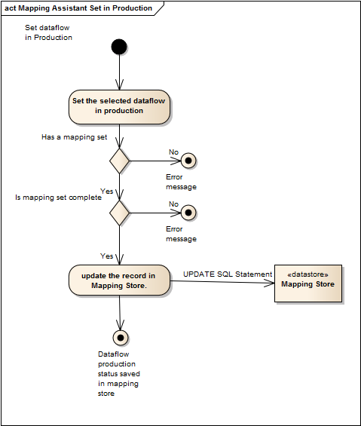
Figure 10 : Activity diagram showing the Set Dataflow in production steps.

An indicative error message referred in Figure 11 can be found below in Figure 12
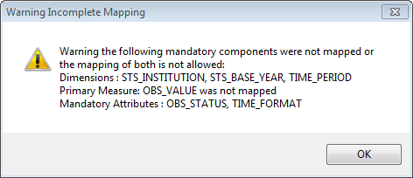
Figure 11: Mapping Assistant Indicative error message when a dataflow cannot be set in production.

NSI Web Service (Java/.NET)
This new feature directly affects the NSI Web Service.

See below a high-level activity flow for Get*Data requests in a NSI WS which includes the “Dataflow in Production” new feature.

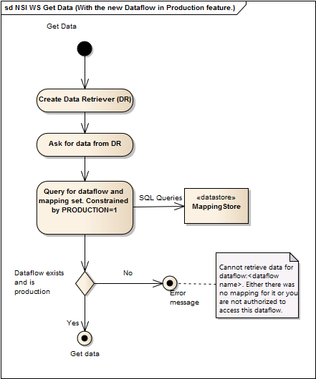
Figure 12: NSI WS activity diagram for Get*Data requests using a version of NSI WS with new dataflow in Production feature.
See below a high-level activity flow for Get*Data requests in a NSI WS version that does not include the “Dataflow in Production” feature.

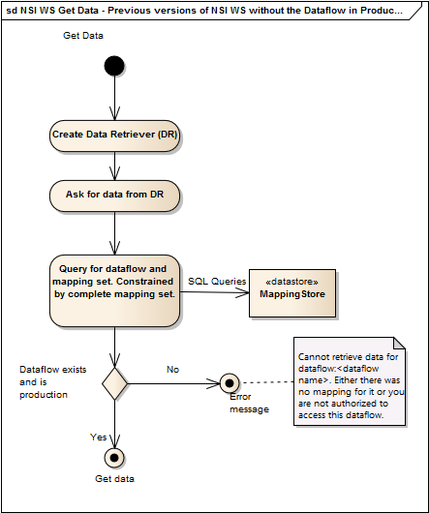
Figure 13: NSI WS activity diagram for Get*Data request using a version of NSI WS without the new dataflow in Production feature.

Below a high-level activity diagram for retrieving one or more dataflows using a GetQueryStructure request in a NSI WS version that includes the new “Dataflow in Production” feature.

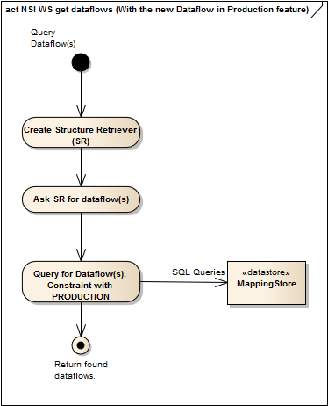
Figure 14: NSI WS activity diagram for GetQueryStructure request using a version of NSI WS with the new dataflow in Production feature

Below a high-level activity diagram for retrieving one or more dataflows using a GetQueryStructure request in a NSI WS version that does not include the new “Dataflow in Production” feature.

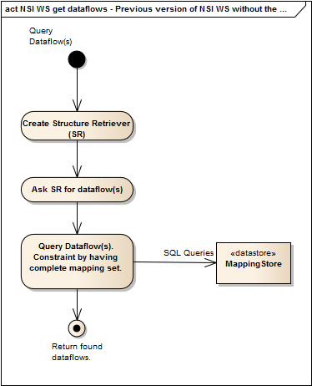
Figure 15: NSI WS activity diagram for GetQueryStructure request using a version of NSI WS without the new dataflow in Production feature

NSI Client
A high-level sequence diagram with NSI Client using an NSI WebService with the new “Dataflow in Production” feature:

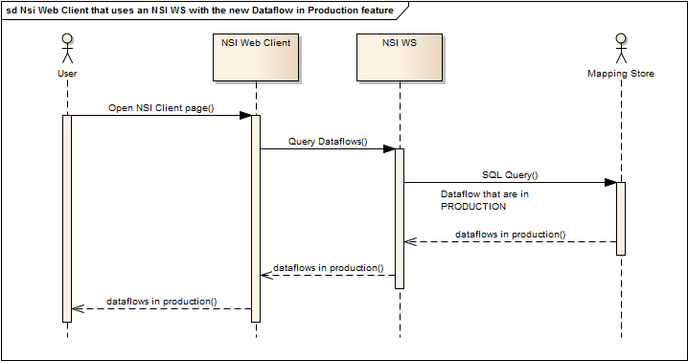
Figure 16: The sequence diagram of NSI Client that uses an NSI WS version that includes the new feature.
Dataflows that are not set in production in Mapping Assistant will not be displayed in NSI Client.

Dataflows that do not have a complete mapping set in Mapping Assistant will not be displayed in NSI Client.

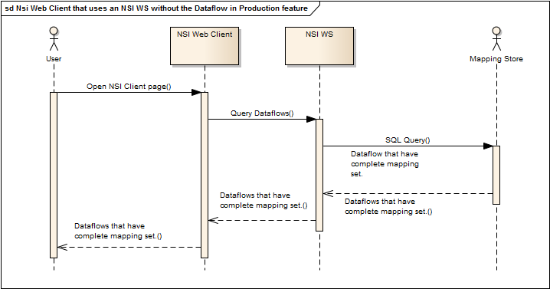
Figure 17: The sequence diagram of NSI Client that uses an NSI WS version that does not include the new feature

Test Auth Config
High-level activity diagram for retrieving one or more dataflows:

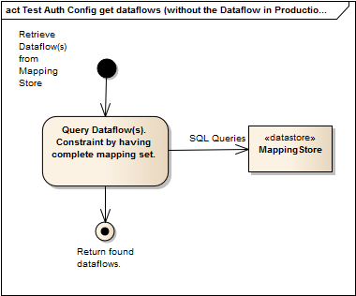
Figure 18: Test Auth Config that does not include support for the Dataflow in Production new feature.
Note: Test Auth Config (any version) is not affected by the new “Dataflow in Production” feature change in Mapping Store.

Test Client
Below a high-level diagram, that shows the interaction of a User with a Test Client version that includes the new “Dataflow in Production” feature.

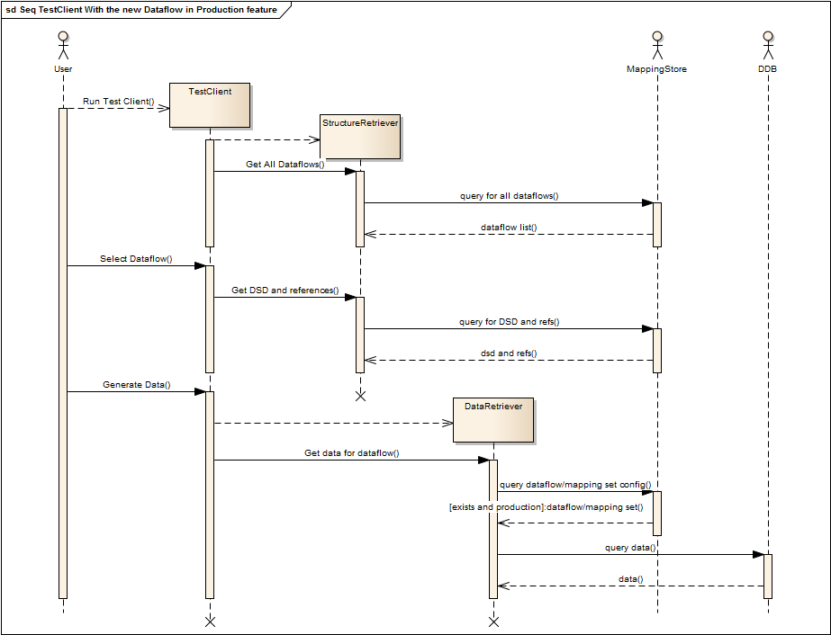
Figure 19: Sequence diagram of a user with a version of Test Client that includes the new Dataflow in Production feature.

Below a high-level diagram, that shows the interaction of a User with a Test Client version that does not include the new “Dataflow in Production” feature.

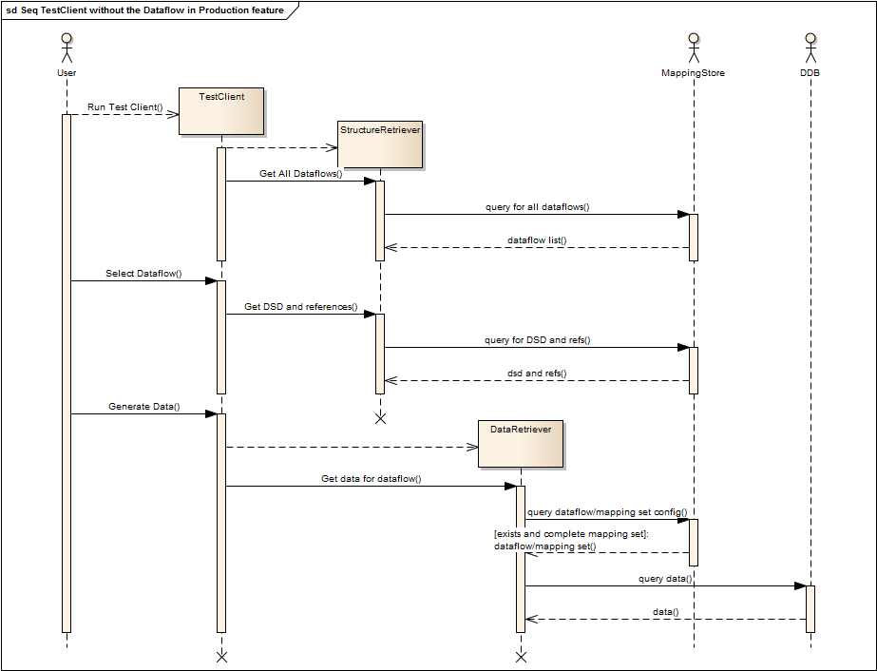
Figure 20: Sequence diagram of a user with a version of Test Client that without the new Dataflow in Production feature.

Below a high-level activity flow after clicking at "Generate Data" at a Test Client version, that includes support for the new “Dataflow in Production” feature.

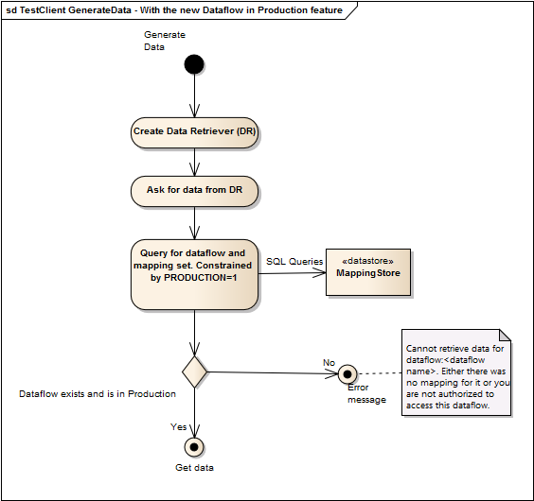
Figure 21: Activity flow of GenerateData with a version of Test Client that includes the new Dataflow in Production feature

This is a high-level activity flow after clicking at "Generate Data" at a Test Client version that without support for the new “Dataflow in Production” feature.

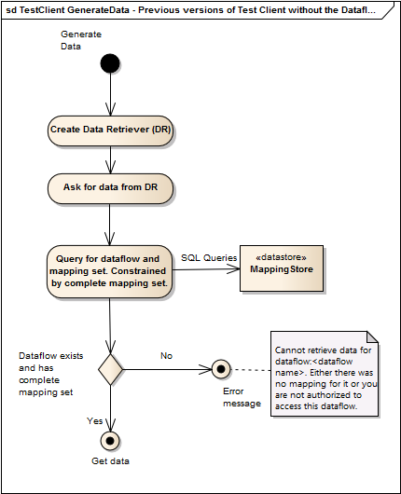
Figure 22: Activity flow of GenerateData with a version of Test Client without the new Dataflow in Production feature

